**Proxy Design Pattern:** The Proxy Design Pattern is a [structural design pattern](https://www.geeksforgeeks.org/structural-design-patterns/) that provides a surrogate or placeholder for another object to control access to it. This pattern is useful when you want to add an extra layer of control over access to an object. The proxy acts as an intermediary, controlling access to the real object.

* And that’s exactly what the Proxy pattern does – ” Controls and manages access to the object they are protecting”.
* As in the decorator pattern, proxies can be chained together. The client, and each proxy, believe it is delegating messages to the real server:

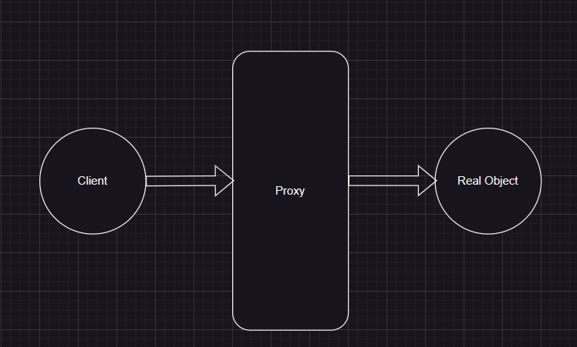

**Chaining of Proxies**

Chaining proxies in the Proxy Design Pattern means connecting them in a sequence, where each proxy adds its behavior or checks before passing the request to the next proxy or the real object. It’s like forming a chain of guards, each responsible for a specific task.



**Components:**

**1. Subject**

The Subject is an interface or an abstract class that defines the common interface shared by the RealSubject and Proxy classes. It declares the methods that the Proxy uses to control access to the RealSubject.

* Declares the common interface for both RealSubject and Proxy.
* Usually includes the methods that the client code can invoke on the RealSubject and the Proxy.

**2. RealSubject**

The RealSubject is the actual object that the Proxy represents. It contains the real implementation of the business logic or the resource that the client code wants to access.

* It Implements the operations declared by the Subject interface.
* Represents the real resource or object that the Proxy controls access to.

**3. Proxy**

The Proxy acts as a surrogate or placeholder for the RealSubject. It controls access to the real object and may provide additional functionality such as lazy loading, access control, or logging.

* Implements the same interface as the RealSubject (Subject).
* Maintains a reference to the RealSubject.
* Controls access to the RealSubject, adding additional logic if necessary.

**Why do we need Proxy Design Pattern?**

The Proxy Design Pattern is employed to address various concerns and scenarios in software development, providing a way to control access to objects, add functionality, or optimize performance.

* **Lazy Loading:**
  + One of the primary use cases for proxies is lazy loading. In situations where creating or initializing an object is resource-intensive, the proxy delays the creation of the real object until it is actually needed.
  + This can lead to improved performance by avoiding unnecessary resource allocation.
* **Access Control:**
  + Proxies can enforce access control policies.
  + By acting as a gatekeeper to the real object, proxies can restrict access based on certain conditions, providing security or permission checks.
* **Protection Proxy:**
  + Protection proxies control access to a real object by adding an additional layer of security checks.
  + They can ensure that the client code has the necessary permissions before allowing access to the real object.
* **Caching:**
  + Proxies can implement caching mechanisms to store results or resources.
  + This is particularly useful when repeated operations on a real object can be optimized by caching previous results, avoiding redundant computations or data fetching.
* **Logging and Monitoring:**
  + Proxies provide a convenient point to add logging or monitoring functionalities.
  + By intercepting method calls to the real object, proxies can log information, track usage, or measure performance without modifying the real object.

